10 Case Interview Examples With Full Worked Solutions
Meta description: WSG founder Stephen Turban works through 10 original case interview examples with full solutions: clarifying questions, structure, math, and the close.

Physics students still get the question Enrico Fermi is said to have put to his classes at the University of Chicago: how many piano tuners are there in Chicago? No phone book, no survey. Start with the city's population, guess what share of households own a piano, how often a piano gets tuned, and how many a tuner can do in a day, and you get a number you can defend. Nobody can prove Fermi used those exact words, but the habit is documented: at the Trinity test in July 1945 he dropped scraps of paper as the shock wave passed, watched how far they blew, and estimated the blast at about 10 kilotons. The instruments later put it at more than twice that.

Every market sizing case in consulting is a Fermi problem, and the other case interview examples below use the same skill: break a vague question into pieces you can estimate, do the arithmetic out loud, and say what the number means. I'm Stephen Turban. I went through McKinsey's on-cycle recruiting out of Harvard, worked at McKinsey, and now run WallStreetGuide, where I prep undergrads for MBB, tier 2, and Big 4 strategy interviews. Most of them have read a dozen case prompts and almost none have read a solution all the way through to the recommendation.

So here are ten original cases, each a different type and a different industry, each worked from the prompt to the close. Every number was computed before it went into a table, so the math ties. Cover the math section, try each one yourself, then compare.

What does a full case interview answer look like?
A full case answer has six parts: restate the prompt, ask two or three clarifying questions, lay out a structure, work the numbers out loud, say what each number means, and close with a recommendation that leads with the answer. The structure is a short list of the two or three things that could explain the problem, not a memorized framework. The math is simple arithmetic done without a calculator, with the result tied back to the question. The close names the recommendation first, then the biggest risk and the next step. If you want the format from the ground up, start with what a case interview is; the ten cases below assume you know the rounds and want to see the answers.

How many practice cases should you do before an interview?
Enough live cases with a partner that you've seen every type below at least once and your weakest type three or four times, which for most students is a few months of steady practice rather than a cram. Reading solved cases, including these, teaches you what good looks like; only speaking them out loud builds the calm you need when the interviewer goes quiet. For MBB internships in Summer 2028, applications are expected to open in early 2027 with first rounds following in the spring [VERIFY: McKinsey, BCG, and Bain careers pages for the Summer 2028 cycle]. A sophomore who starts this fall can see every case type here twice before applications open.

Profitability and revenue growth case interview examples
Profitability and growth cases are the two most common first-round cases, and both start from the same split: revenue is price times volume, and profit is revenue minus cost. The skill is finding which piece moved, and then sizing the fix. Every case in this article follows the structure the firms grade on, which you can see in these 7 case interview frameworks: use the frameworks as a checklist for breadth, then build your own tree for the case in front of you.

1. A regional airline's profit collapses while revenue grows (profitability, airlines)

The airline case tests whether you can separate a price effect from a volume effect inside a single cost line.

The prompt: "Our client is a regional airline that flies 40 small jets on short routes across the Mountain West. Over the last two years revenue grew 5 percent, but operating profit fell from $60 million to $20 million. The CEO wants to know why, and what to do about it."

Clarifying questions and answers:

- Is operating profit measured before interest and taxes? Yes. It's revenue minus the cost of running the airline, before financing and tax.
- Did the fleet or the route map change? The fleet stayed at 40 jets. The airline added a few flights a day on existing routes, so flights and passengers are both up about 5 percent.
- Did fares change, and what did competitors do? The client's average fare is flat. A larger competitor flies six of the client's 30 routes and raised its fares.

Structure: Profit is revenue minus cost, so a 5 percent revenue gain next to a two-thirds profit drop means costs rose far faster than revenue. On the revenue side, I'd check passengers and average fare separately. On the cost side, an airline's big lines are fuel, crew and staff, maintenance, airport fees, and the cost of owning or leasing the planes. Fuel moves with the market, so my first hypothesis is that fuel got more expensive while fares stayed put. When revenue grows and profit collapses, the cause is almost always a cost line the company doesn't control and a price it chose not to change.

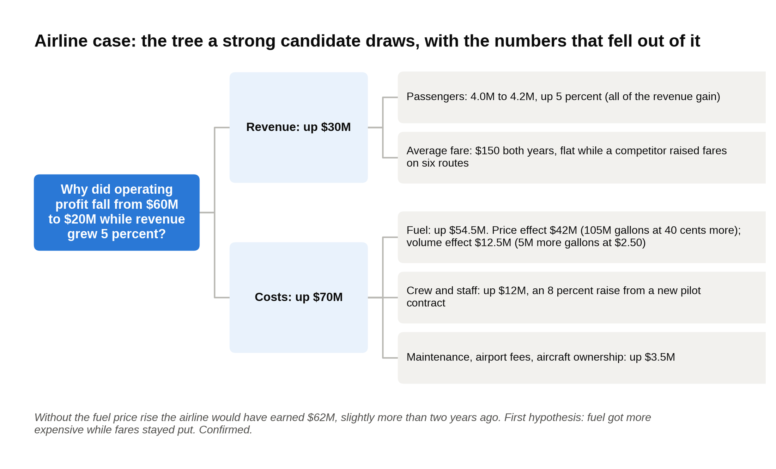
The profit tree for case 1: revenue rose $30 million on volume alone, and $42 million of the $70 million cost increase is the fuel price.

The data:

 | Two years ago | Today
Passengers | 4.0 million | 4.2 million
Average fare, including bag and seat fees | $150 | $150
Revenue | $600 million | $630 million
Fuel burned (gallons) | 100 million | 105 million
Fuel price per gallon | $2.50 | $2.90
Fuel cost | $250 million | $304.5 million
Crew and staff | $150 million | $162 million
Maintenance, airport fees, aircraft ownership | $140 million | $143.5 million
Total operating cost | $540 million | $610 million
Operating profit | $60 million | $20 million

The math:

- Revenue: 4.2 million × $150 = $630 million, up $30 million from $600 million. All of it is volume, since the fare didn't move.
- Total cost rose $70 million, from $540 million to $610 million. Revenue up $30 million, cost up $70 million, so profit fell $40 million.
- Fuel rose $54.5 million. Split it two ways. Price effect: the 105 million gallons flown today cost 40 cents more each, 105 million × $0.40 = $42 million. Volume effect: the extra 5 million gallons at the old price, 5 million × $2.50 = $12.5 million. $42 million + $12.5 million = $54.5 million.
- Crew and staff rose $12 million, an 8 percent raise from a new pilot contract. The other lines rose $3.5 million.
- Check the story without the fuel price increase: $60 million + $30 million of revenue, minus $12.5 million of extra fuel burned, minus $12 million of labor, minus $3.5 million of other costs = $62 million. The airline would have earned slightly more than two years ago.
- Margin fell from 10 percent ($60M ÷ $600M) to about 3 percent ($20M ÷ $630M).
- A 16 percent rise in the price of fuel cost the airline $42 million, which is the entire $40 million profit decline and then some; everything else the airline did netted out to a $2 million gain.

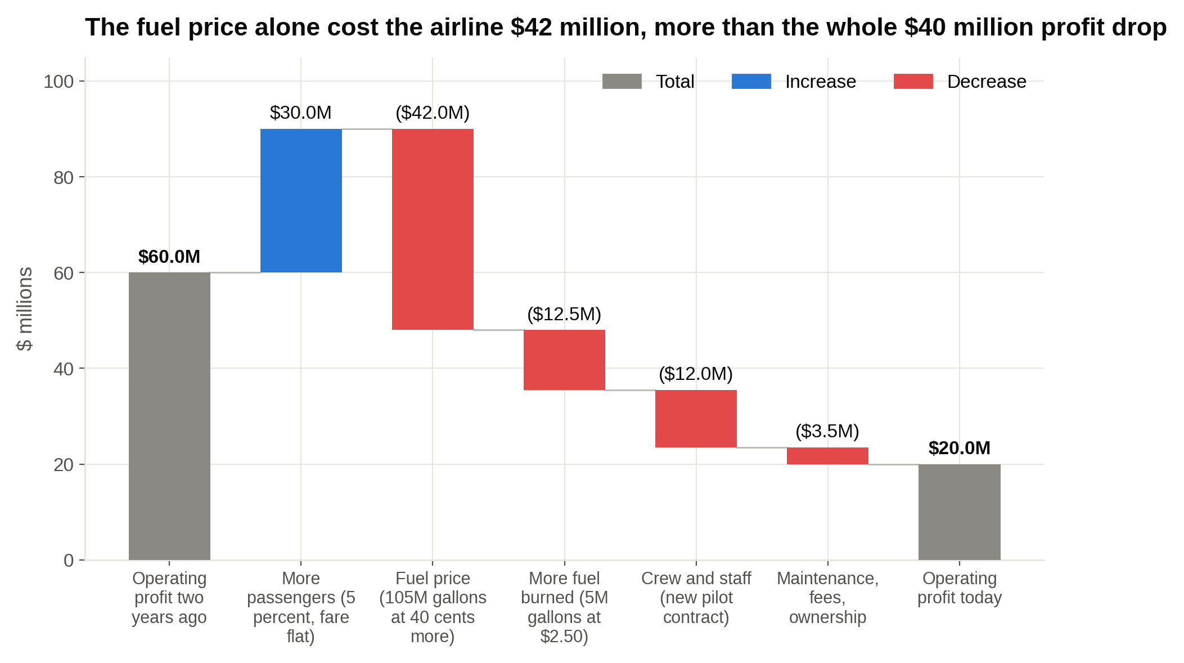
Walk the bridge and the story is one bar: the 40 cent fuel price rise took $42 million, and everything else the airline did netted out to a $2 million gain.

The so what: Fuel is half of this airline's cost base, its price rose 16 percent, and the airline passed none of it to customers. A competitor on six of its routes did.

A strong recommendation: "Profit fell $40 million because fuel got 16 percent more expensive and the airline kept fares at $150. I'd raise the average fare to $165, matching the competitor. The client's own history says a 10 percent fare increase loses about 5 percent of passengers, so 3.99 million passengers × $165 = $658.4 million, about $28 million more revenue and roughly $48 million of profit. Cutting the three thinnest routes, which lose $4 million a year together, gets to about $52 million. Hedging fuel smooths next year's number but doesn't fix this one. The main risk is losing more passengers than history suggests on the six contested routes, so I'd raise fares there last and watch bookings weekly."

What separates a strong candidate from an average one: An average candidate sees fuel up $54.5 million and says "hedge fuel." A strong candidate splits the $54.5 million into the $42 million price effect and the $12.5 million volume effect, notices the fare never moved while a competitor's did, and prices the fare lever with an explicit elasticity assumption.

Airlines live and die on how hard they work each plane. In 1972 Southwest was down to four jets and almost no cash, sold one to stay alive, and kept its full schedule with three by turning each plane around at the gate in 10 minutes. A plane on the ground earns nothing while its fixed costs keep running, and that logic is what a profitability case about any asset-heavy business comes down to.

Split every cost increase into price and volume before you recommend anything, because the two have different fixes.

2. A gym chain wants to grow revenue 50 percent in three years (revenue growth, fitness)

The gym case tests whether you can size each growth lever and then say honestly whether they add up to the target.

The prompt: "Our client runs 60 mid-price gyms across the Southeast and brings in $90 million a year. The new CEO wants $135 million within three years. How do they get there?"

Clarifying questions and answers:

- Is the goal revenue at any cost, or does profit matter? Revenue is the target, but every lever has to at least break even on profit.
- Organic only, or are acquisitions on the table? Both, though the board prefers organic growth.
- What does the revenue look like today? 120,000 members paying $50 a month, plus personal training, which 10 percent of members buy at $125 a month.
- How full are the gyms? About 70 percent of comfortable capacity, so there's room for more members without building anything.

Structure: Revenue is members times monthly dues, plus the members who buy extras times what they pay, added up across all the gyms. That gives four levers: more gyms, more members per gym, a higher price per member, and more spend per member on things like training. I'd size each one with the client's data and then add them up, because the interviewer wants to know whether the levers reach $135 million by year three, not which levers exist. Growth cases are won by sizing each lever and adding them up, not by listing them.

The data:

 | Today | What the interviewer gives you
Gyms | 60 | A new gym costs $3 million and reaches a mature 2,000 members by its third year (about 70 percent of mature revenue in year two, 35 percent in year one)
Members per gym | 2,000 | Comfortable capacity is 2,850
Monthly dues | $50 | A $5 increase would lose about 3 percent of members
Premium tier | None | An $80 tier with towel service, classes, and guest passes; about 20 percent of members would take it
Personal training | 10 percent of members at $125 a month | Hiring more trainers could lift that to 15 percent
Revenue | $72 million dues + $18 million training = $90 million | Target: $135 million in year three

The math:

- Today: 120,000 members × $50 × 12 = $72 million in dues. 12,000 training buyers × $125 × 12 = $18 million. Total $90 million. The gap to $135 million is $45 million.
- Lever A, dues to $55: lose 3 percent of members, so 116,400 remain. 116,400 × $55 × 12 = $76.8 million, up $4.8 million.
- Lever B, premium tier: 20 percent of 116,400 is 23,280 members paying $80 instead of $55, an extra $25 each. 23,280 × $25 × 12 = $7.0 million.
- Lever C, training to 15 percent: 17,460 buyers × $125 × 12 = $26.2 million, up $8.2 million from $18 million.
- Existing gyms in year three: $76.8 million + $7.0 million + $26.2 million = $110.0 million. That's $20 million of the $45 million gap from the gyms the client already has.
- Lever D, 15 new gyms, five a year, valued at today's pricing so the levers stay separate: a mature gym earns 2,000 × $50 × 12 + 200 × $125 × 12 = $1.5 million. In year three the first five are mature ($7.5 million), the second five are at 70 percent ($5.25 million), and the third five are at 35 percent ($2.6 million). Total $15.4 million.
- Year three total: $110.0 million + $15.4 million = $125.4 million.
- The four levers reach about $125 million in year three, $10 million short of the $135 million target, because gyms opened in years two and three haven't filled up yet.

The so what: The shortfall is a ramp problem: 15 new gyms are worth $22.5 million at maturity but only $15.4 million by year three. The client either buys a chain that is already full (about seven mature gyms) or accepts that $135 million arrives in year four.

A strong recommendation: "The client can get to roughly $125 million in three years organically: a $5 dues increase, a premium tier, more personal training, and 15 new gyms. That's $35 million of the $45 million gap. The last $10 million needs an acquisition of a six-to-eight gym chain in a market they don't serve, or a fourth year. I'd make the pricing and training moves this quarter because they cost almost nothing, open the first new gyms in the three strongest markets, and run the acquisition search in parallel. The risk I'd watch is churn from the dues increase; if it runs above 5 percent instead of 3, launch the premium tier first so members see something new before the price moves."

What separates a strong candidate from an average one: An average candidate names the levers and stops. A strong candidate sizes each one, removes the members lost to the price increase before applying the next lever, notices that a gym opened in year three earns a third of its mature revenue, and tells the CEO the target is a stretch rather than forcing the numbers to fit.

Say plainly when the levers don't reach the target, because a CEO would rather hear "$125 million in three years" than a plan built on gyms that aren't full yet.

Market entry, M&A, and pricing case interview examples
Market entry, acquisition, and pricing cases all come down to the same question: does the money the client puts in come back with enough on top, and how sure are we? The structure differs, but each one ends in a payback, a break-even, or a value-versus-price comparison. The M&A case runs longest of the ten because the interviewer hands you the most data and expects the most judgment about what's uncertain.

3. A convenience store chain considers EV fast chargers (market entry, EV charging)

The EV charging case tests whether you can find the one variable the whole decision hangs on and build the recommendation around it.

The prompt: "Our client operates 1,200 gas station convenience stores across the Midwest. Management is asking whether to install DC fast chargers, the kind that charge an electric car in 20 to 40 minutes. Should they, and if so, where and how many?"

Clarifying questions and answers:

- What's the objective: profit from selling electricity, or more people in the store? Both, and the client wants a payback inside five years on anything it builds.
- Is there a capital budget? Up to $200 million over five years.
- Does the client own its sites? About 80 percent, so landlord approval isn't the issue.
- How many electric cars are on the roads in their region? Roughly 3 percent of cars today, projected to reach about 10 percent in five years.

Structure: Four questions. Is the market attractive: how many EVs, how fast is that growing, and who else is building chargers along the same roads? Can the client win: it has highway sites, 24-hour stores, restrooms, and food, which matter when a driver has to wait 30 minutes. Do the unit economics work: what does a site cost to build, how many cars use it a day, what's the margin per kilowatt-hour, and what does the driver spend inside? And what could go wrong: utilization that lags, electricity rate structures, charger standards changing. In a market entry case, the economics of a single site decide the answer, so get to the per-site math fast.

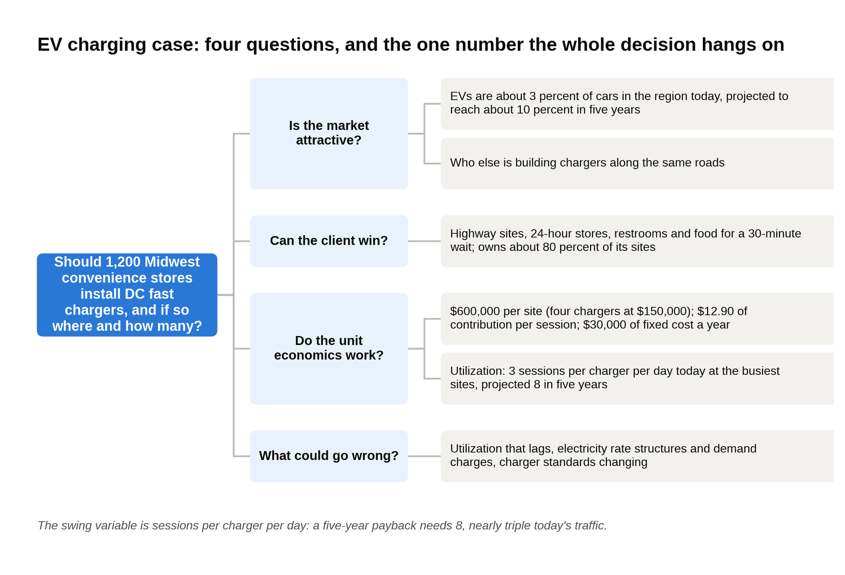
The market entry tree for case 3 ends at one number, sessions per charger per day, and the recommendation is built around learning it.

A kilowatt-hour, or kWh, is the unit electricity is sold in; a fast-charging session puts about 35 kWh into a typical car. Utilization is how many sessions a charger handles in a day, and it's the number everything else depends on.

The data (per site, four chargers):

Item | Value
Installed cost per charger, including the grid connection | $150,000, so $600,000 per site
Price charged to drivers | $0.45 per kWh
Electricity cost, including demand charges from the utility | $0.15 per kWh
Energy per session | 35 kWh
In-store spend per session | $8 at a 30 percent margin, so $2.40
Fixed cost per site (maintenance, software, payment fees) | $30,000 a year
Sessions per charger per day | 3 today at the busiest sites; projected 8 in five years

The math:

- Margin per session: 35 kWh × ($0.45 minus $0.15) = 35 × $0.30 = $10.50 on electricity, plus $2.40 inside the store, so $12.90 per session.
- At 8 sessions per charger per day: 4 chargers × 8 × 365 = 11,680 sessions a year. 11,680 × $12.90 = $150,672, minus $30,000 fixed = about $120,700 a year. Payback: $600,000 ÷ $120,700 = 5.0 years.
- At today's 3 sessions per charger per day: 4,380 sessions. 4,380 × $12.90 = $56,502, minus $30,000 = $26,502. Payback: $600,000 ÷ $26,502 = 22.6 years.
- Break-even for a five-year payback: the site needs $120,000 a year after fixed costs, so $150,000 of contribution. $150,000 ÷ $12.90 = 11,628 sessions, which is 31.9 a day across four chargers, or 8 per charger.
- Scale: 50 pilot sites cost $30 million. All 1,200 would cost $720 million, more than three times the budget.
- A site pays back in five years only at about 8 sessions per charger per day, nearly triple today's traffic, so the decision is a bet on where EV adoption arrives first.

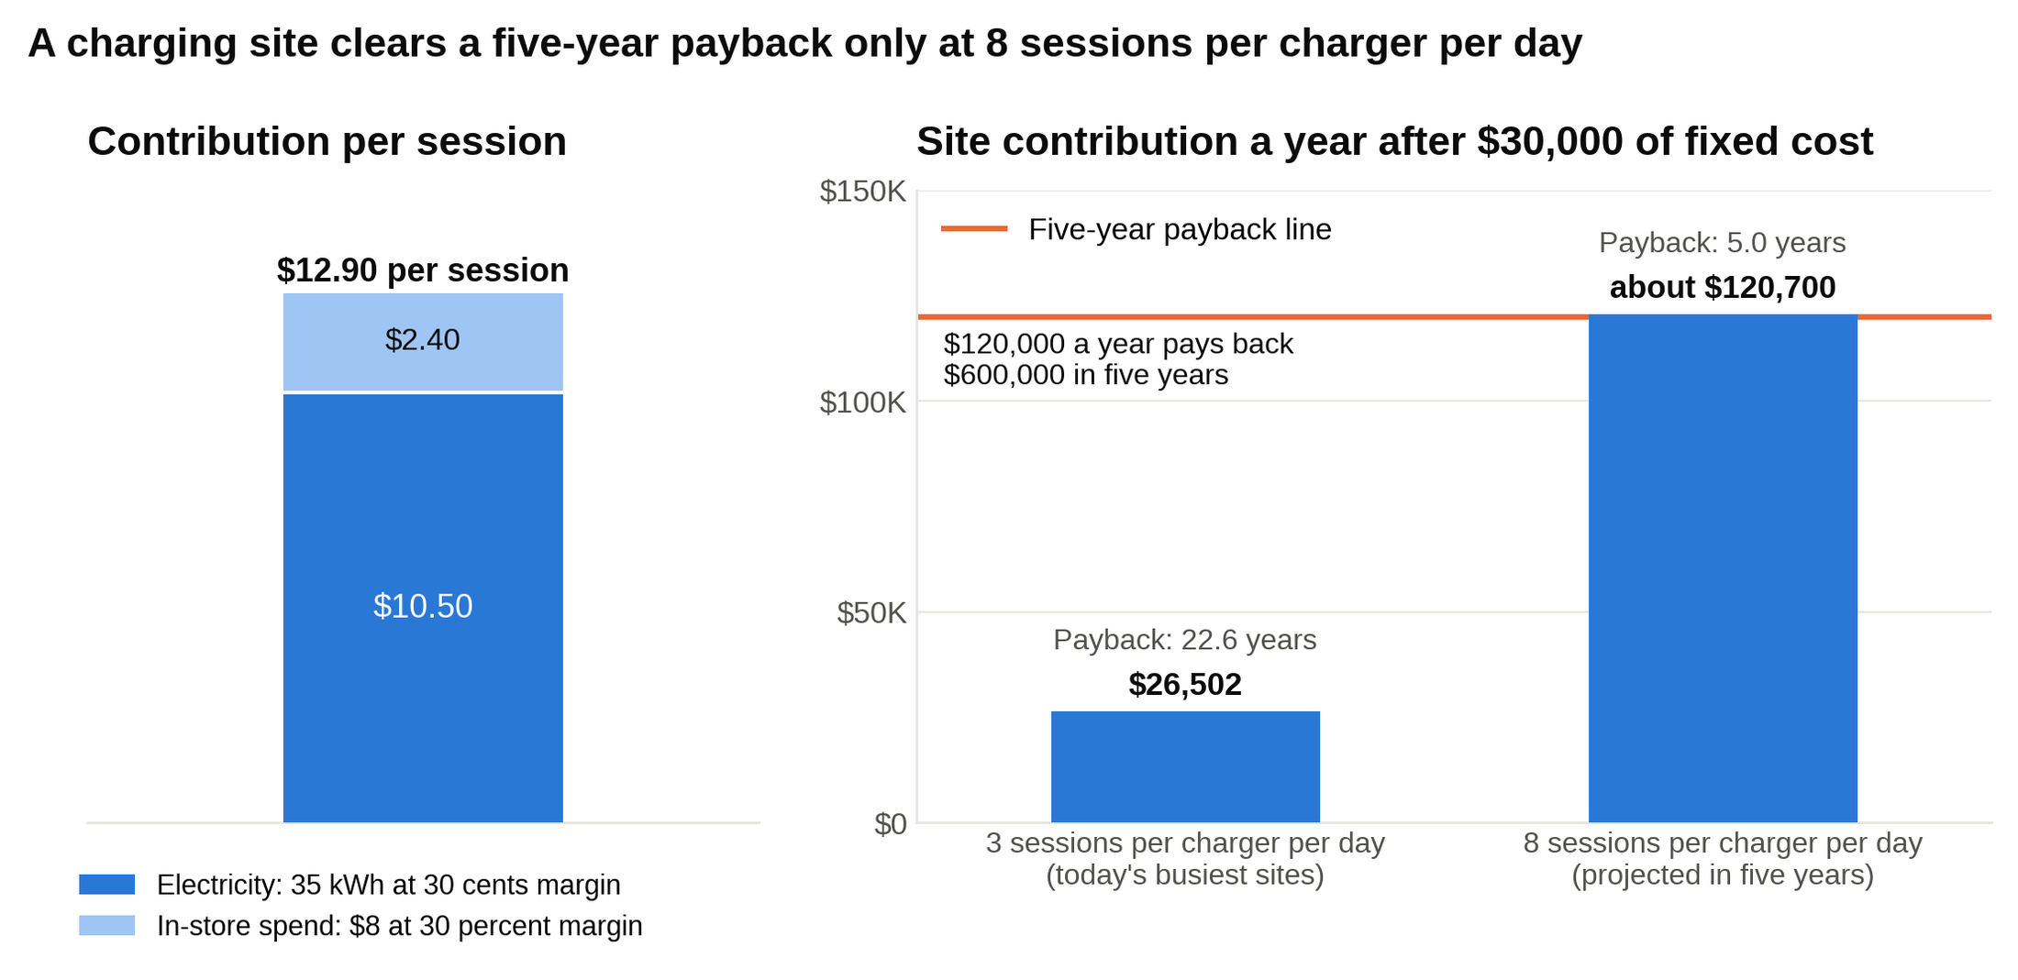
Each session earns $12.90, so a site clears the $120,000 a year that a five-year payback needs only at 8 sessions per charger per day, not today's 3.

The so what: The economics work only where utilization reaches 8 sessions a day, which today is nowhere and in five years will be a subset of highway corridor sites. Find those sites early, build there, and let the data decide the next wave. The in-store margin matters too: $2.40 a session is nearly a fifth of the contribution, and it's the part competitors without a store can't match.

A strong recommendation: "Enter, but with a 50-site pilot on highway corridors, not a chain-wide rollout. That's $30 million of the $200 million budget. Pick sites by today's traffic counts and EV registrations within 20 miles, measure sessions per charger for 18 months, and expand only where utilization is on track to pass 8 a day. Use any federal or state incentive that covers part of the install cost [VERIFY: current status of the federal NEVI charging program and Midwest state incentives], and negotiate electricity rates with the utility before building, since demand charges can wipe out the 30-cent margin. The risks are slower EV adoption, competitors building first on the same corridors, and charger standards changing; the pilot limits all three."

What separates a strong candidate from an average one: An average candidate argues that EVs are the future and recommends building everywhere. A strong candidate finds that utilization is the swing variable, computes the break-even sessions per day, and turns it into a staged rollout with a trigger the client can measure.

When one assumption decides the whole case, name it, compute its break-even, and design the recommendation so the client learns that number before committing the money.

4. A salty snack maker weighs buying a popcorn brand (M&A, packaged food)

The snack case tests whether you can separate what a company is worth on its own from what it's worth to this buyer, and then decide who should keep the difference.

The prompt: "Our client is a $2 billion revenue maker of chips and pretzels. It has the chance to buy a popcorn and puffed-snack company with $400 million of revenue for $1.2 billion. Should it?"

Clarifying questions and answers:

- Why does the client want this? It's weak in better-for-you snacks, the fastest-growing part of the aisle, and the target is strong there.
- How profitable is the target? EBITDA of $60 million, a 15 percent margin. EBITDA is operating profit with depreciation added back, a rough measure of the cash a business throws off, and it's what deals get priced on.
- What have similar companies sold for? Recent snack deals have gone for about 14 times EBITDA.
- How does the target get its product to stores? Through third-party distributors who take about 8 percent of revenue. The client runs its own delivery trucks to 40,000 stores.
- Can the client afford it? Yes, with cash and debt; financing isn't the constraint.

Structure: Three questions decide an acquisition. What is the target worth standing alone, compared with the price? What extra value does this particular buyer create: cost synergies from combining operations and revenue synergies from selling the target's products through the buyer's channels? And what could go wrong: integration, cannibalizing the client's own products, paying for synergies before they exist. A fourth question sits underneath: what else could the client do with $1.2 billion? Deals are won or lost on the gap between standalone value and price, and that gap has to be covered by synergies the buyer can actually deliver.

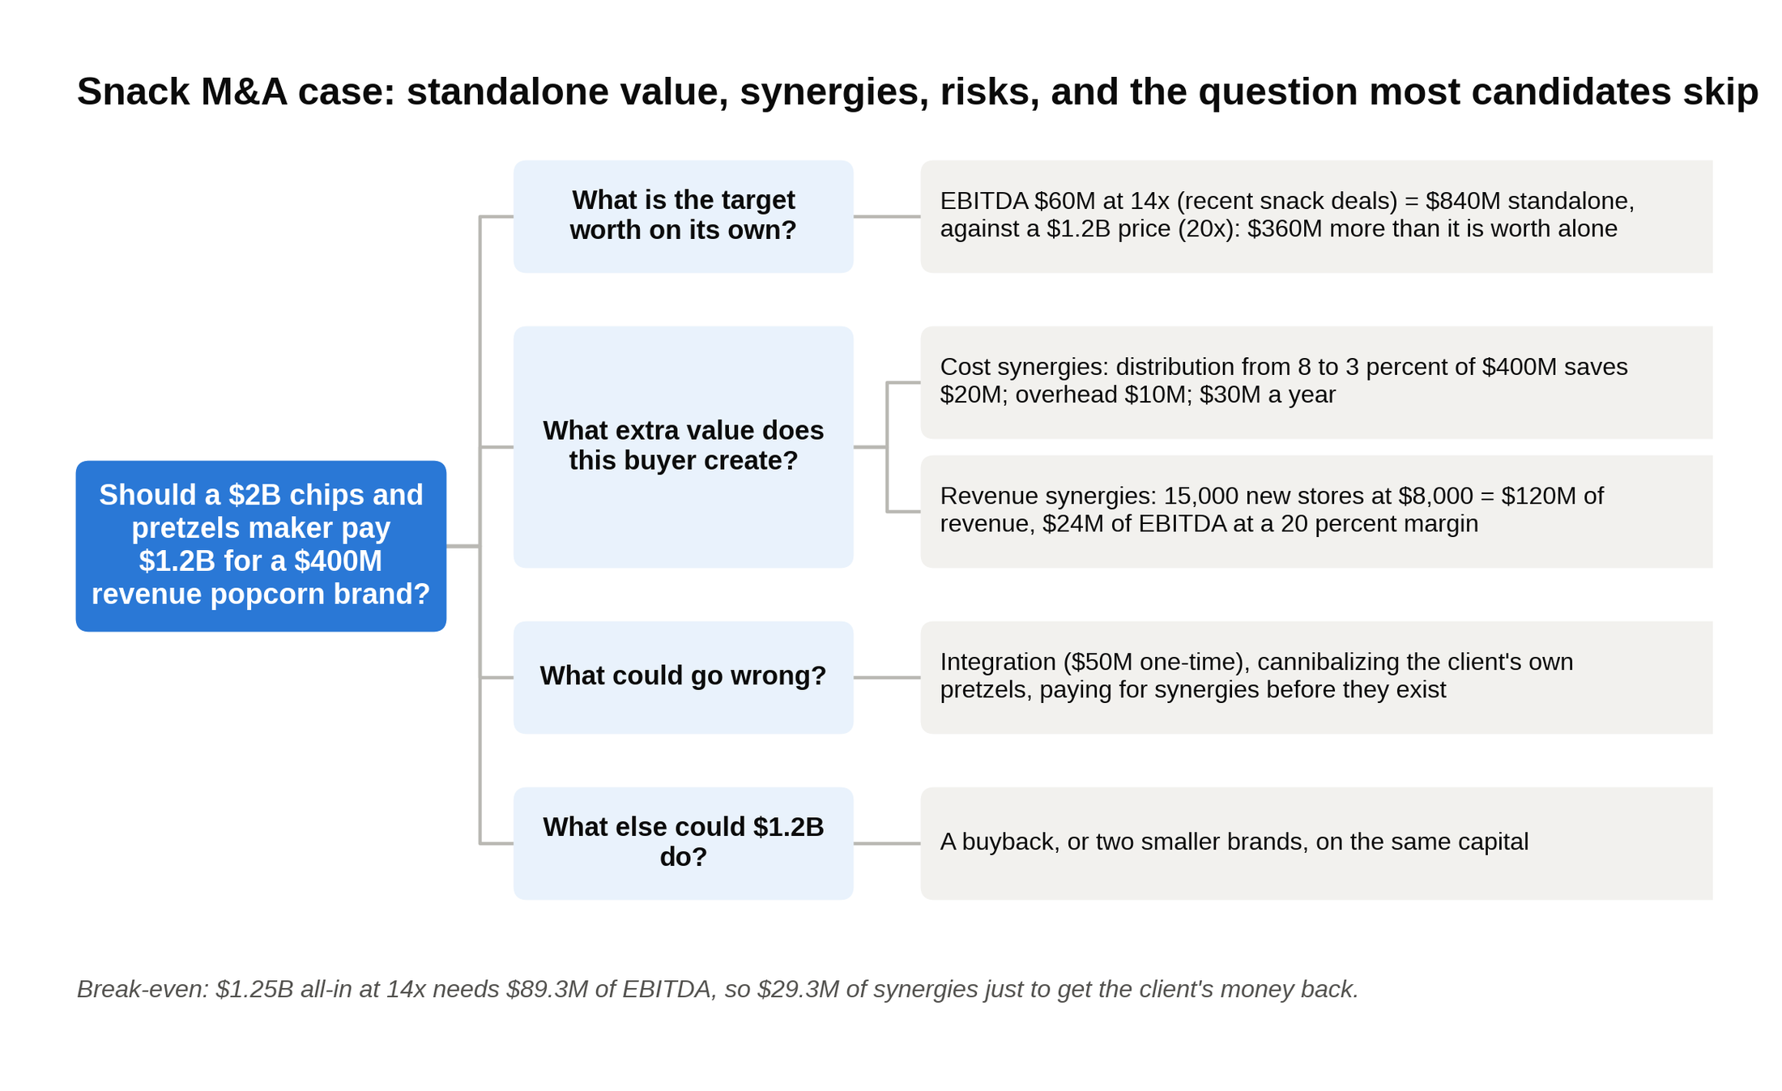
The acquisition tree for case 4: the price sits $360 million above standalone value, and the synergies have to cover the gap.

The data:

Item | Value
Target revenue | $400 million
Target EBITDA | $60 million (15 percent margin)
Asking price | $1.2 billion
Recent snack deal multiple | 14x EBITDA
Target's distribution cost (third parties) | 8 percent of revenue
Cost to carry the product on the client's own trucks | 3 percent of revenue
Overhead savings (duplicate finance, HR, offices) | $10 million a year
Stores carrying the target today | 25,000
Stores the client reaches | 40,000
Expected revenue per new store | $8,000 a year, half the target's current average
Contribution margin on added revenue | 20 percent
One-time integration cost | $50 million

The math:

- Price multiple: $1.2 billion ÷ $60 million = 20x EBITDA, against 14x for comparable deals.
- Standalone value at the market multiple: 14 × $60 million = $840 million. The client would be paying $360 million more than the target is worth on its own.
- Cost synergies: moving distribution from 8 percent to 3 percent of $400 million saves $20 million a year. Overhead saves $10 million. Total $30 million a year.
- Revenue synergies: 40,000 minus 25,000 = 15,000 new stores. 15,000 × $8,000 = $120 million of new revenue. At a 20 percent contribution margin, $24 million of EBITDA.
- Full case: $60 million + $30 million + $24 million = $114 million of EBITDA. At 14x that's $1,596 million. Minus the $1.2 billion price and $50 million of integration cost: $346 million of value created.
- Cost synergies only: $60 million + $30 million = $90 million. At 14x, $1,260 million. Minus $1.25 billion all-in: $10 million. Break-even.
- Break-even synergies: $1.25 billion ÷ 14 = $89.3 million of EBITDA needed, so $29.3 million of synergies just to get the client's money back.
- At $1.2 billion the client needs $29 million of synergies just to break even, nearly the whole $30 million cost case, so the seller is being paid for the cost synergies up front and the client's only upside is the unproven revenue case.

The so what: The strategic logic is sound and the cost synergies are real, because the client's trucks already drive past those stores. The price is the problem. At $1.2 billion the seller captures all of the cost synergies and the client takes all of the execution risk. The revenue synergies are plausible but unproven: the target's current stores average $16,000 a year, and the $8,000 assumption for new stores is a guess until the top five retailers confirm shelf space.

Real buyers talk about deals exactly this way. When Hershey agreed to buy Amplify Snack Brands, the maker of SkinnyPop, for about $1.6 billion in December 2017, it paid a 71 percent premium to the stock price and told investors the deal was 14.8 times EBITDA "including the synergy savings," about $20 million a year. Quoting the multiple with synergies is how an acquirer makes a high headline price look reasonable, and it's the move an interviewer wants you to catch.

A strong recommendation: "Pursue the deal, but not at $1.2 billion. I'd offer about $1.05 billion, which is 14 times the target's $60 million plus half of the $30 million in cost synergies. At that price the client keeps half the cost synergies and all of the revenue upside, and it still breaks even if the new-store revenue never shows up. Three risks: cannibalizing the client's own pretzels on the same shelf, losing the founder-led team that built the brand, and termination fees on the target's distributor contracts. Next steps: pull route data to confirm the 5-point distribution saving, get the top five retailers to confirm they'd add the brand in the 15,000 new stores, and check whether the client's trucks have the capacity. If the seller won't move below $1.2 billion, I'd walk, because a buyback or two smaller brands would return more on the same capital."

What separates a strong candidate from an average one: An average candidate computes 20x, calls it expensive, and says no. A strong candidate values the target standalone, builds the synergy case line by line, finds the break-even, and prices the offer from it. The strong candidate also asks the question most people skip: what else could the client do with $1.2 billion?

Never pay for synergies up front; price the deal so the seller gets the standalone value and the buyer keeps most of what the buyer creates.

5. A software company's rival launches at 40 percent off (pricing, software)

The software pricing case tests whether you can resist a blanket price cut and segment customers by what they're willing to pay.

The prompt: "Our client sells project-management software to small businesses at $20 per user per month. A well-funded competitor just launched a similar product at $12. The CEO wants to know whether to cut to $12."

Clarifying questions and answers:

- How big is the business? 50,000 customers averaging 10 users each, so 500,000 seats. That's $120 million of annual recurring revenue, the yearly value of all active subscriptions.
- What does it cost to serve a seat? Gross margin is 80 percent, so most of each dollar is profit after the software exists.
- Is churn moving? Churn, the share of customers who cancel each month, is 2 percent and has ticked up only among the smallest customers.
- Do customers pick on price? A survey says the smallest teams do; teams over 20 users care more about integrations and support, which the competitor lacks.

Structure: First, what would matching the price do, and how many new seats would it take to make the revenue back? Second, who would actually leave, because a $12 competitor doesn't threaten every customer equally. Third, what are the alternatives: hold price, add tiers, or discount only where the threat is real. Fourth, how does the competitor respond, and can the client reverse the move if it's wrong. A price cut is the easiest decision to make and the hardest to undo, so the first job in a pricing case is to measure what it costs.

The data:

Item | Value
Seats | 500,000 at $20 a month, $120 million ARR
Gross margin | 80 percent
Small customers (under 5 users) | 30 percent of customers, 10 percent of seats
Mid-size (5 to 20 users) | 50 percent of customers, 50 percent of seats
Large (over 20 users) | 20 percent of customers, 40 percent of seats
Survey: would downgrade to a $12 limited tier | 20 percent of seats
Survey: would upgrade to a $30 tier with advanced reporting and priority support | 15 percent of seats
New customers a $12 tier would win from the competitor | About 15,000 companies at 5 seats each

The math:

- Match at $12 across the board: 500,000 × $12 × 12 = $72 million. The client gives up $48 million a year on day one.
- Seats needed to earn that back at $12: $120 million ÷ ($12 × 12) = 833,333, a 67 percent increase in seats just to stand still.
- Worst case if the client holds price and loses every small customer: 10 percent of seats = 50,000 × $20 × 12 = $12 million. Painful, but a quarter of the cost of matching.
- Three-tier alternative. Downgrades: 100,000 seats move from $20 to $12, a loss of $8 each, 100,000 × $8 × 12 = a $9.6 million loss. Upgrades: 75,000 seats move from $20 to $30, 75,000 × $10 × 12 = +$9.0 million. New starter customers: 15,000 × 5 seats × $12 × 12 = +$10.8 million.
- Net of the three-tier move: $9.0 million + $10.8 million minus the $9.6 million lost on downgrades = +$10.2 million a year.
- Matching the competitor costs $48 million a year with certainty, losing every small customer costs $12 million, and a three-tier structure nets about +$10 million, so the blanket cut is the worst of the three by a wide margin.

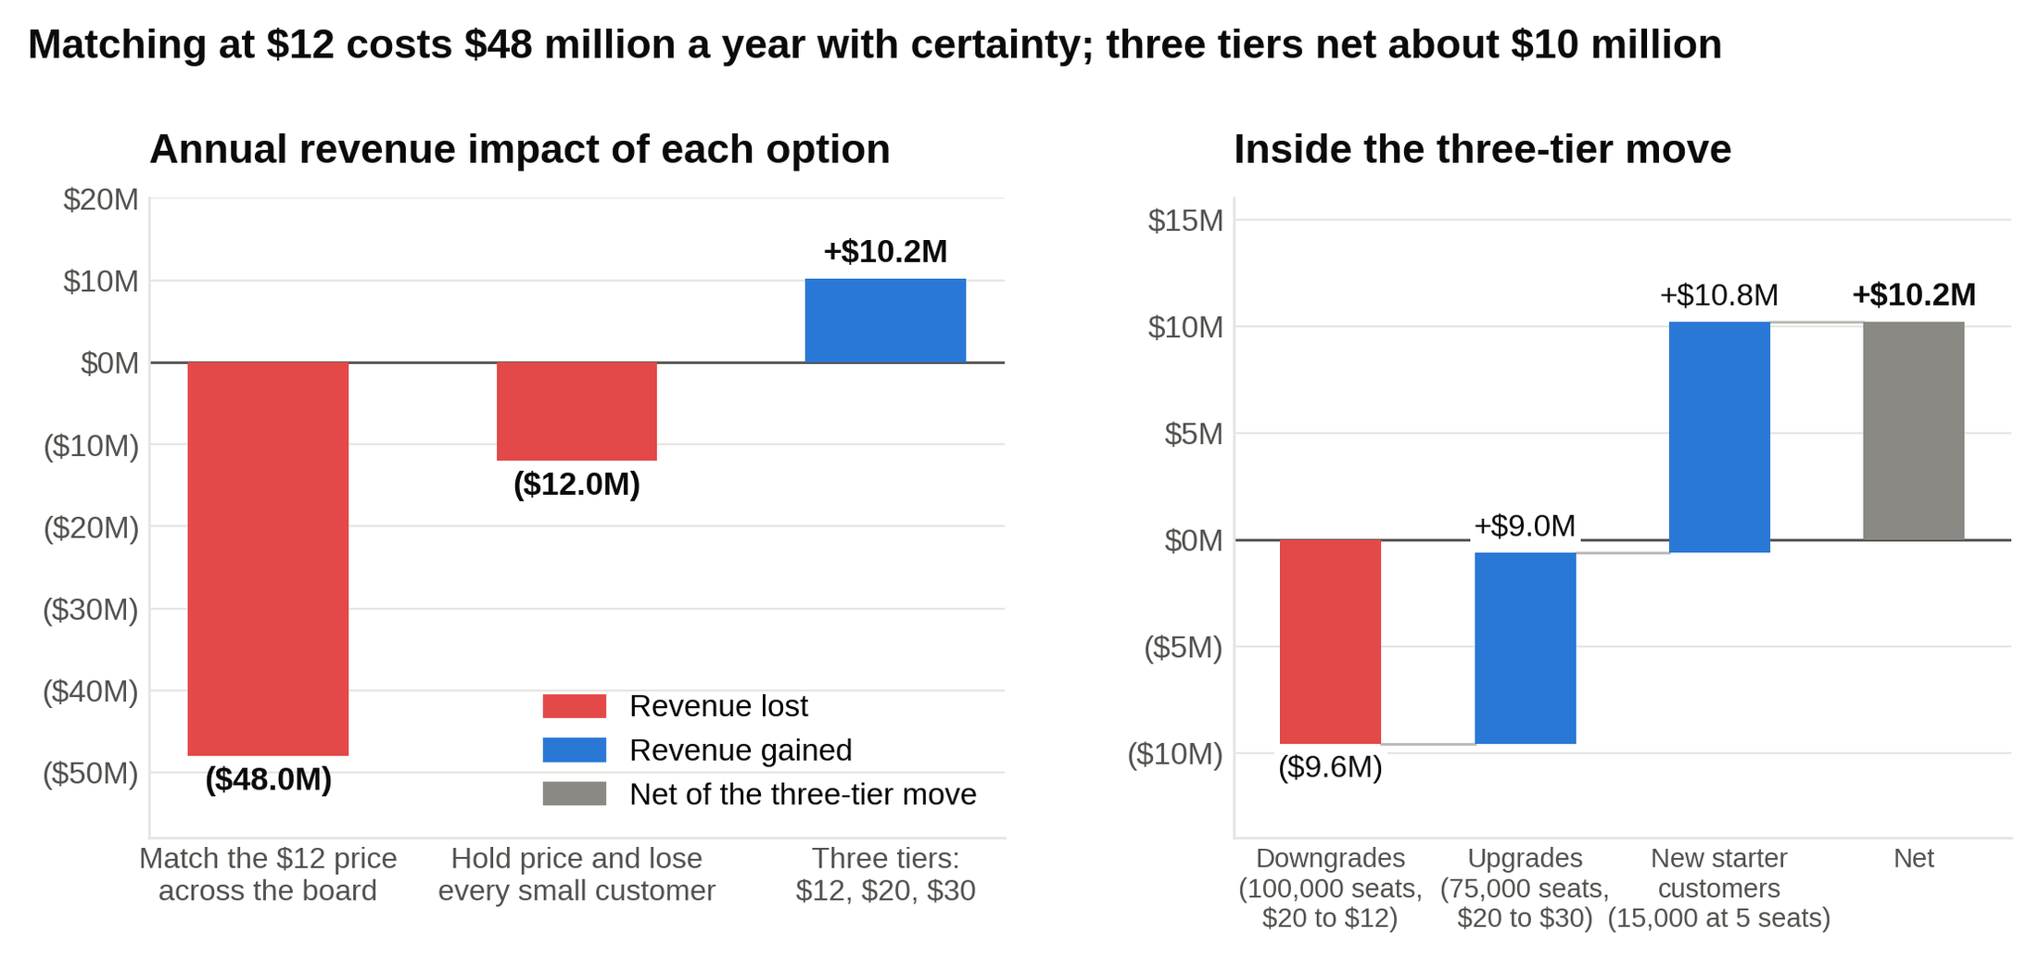
The blanket cut gives up $48 million a year on day one; three tiers lose $9.6 million on downgrades and win it back twice over on upgrades and new starters.

The so what: Most of this client's revenue sits with customers who aren't shopping on price. A $12 tier gives the small teams a place to land, a $30 tier charges the large teams for what they already value, and the $20 middle stays put. The 80 percent gross margin is the trap: it makes any seat look profitable, which tempts CEOs into cuts that cost more than the customers they save.

A strong recommendation: "Don't match. Launch three tiers: a $12 starter with limits on projects and no integrations, the current product at $20, and a $30 tier with advanced reporting and priority support. The survey math says that nets about $10 million a year against a $48 million hit from cutting across the board. Risks: more customers downgrade than the 20 percent the survey suggests, the competitor cuts again, and support costs on the starter tier run high. Next steps: offer the tiers to new customers first for 90 days to measure the real downgrade rate before opening them to existing accounts, and track churn among small customers weekly."

What separates a strong candidate from an average one: An average candidate reasons that software has almost no cost per seat, so any customer kept is profit, and recommends matching. A strong candidate computes the 67 percent seat increase the cut would need, segments customers by willingness to pay, and treats the cut as close to irreversible.

Answer a competitor's price with structure, not with a cut, because segmenting customers by willingness to pay protects the revenue that was never at risk.

Market sizing case interview examples
Market sizing cases grade the chain of assumptions and the sanity check, not the final number, and they run shorter than any other case type. Two methods exist. Top-down starts from a population and ratios down to the thing you're counting. Bottom-up starts from one unit, a store or a screen, and builds up. Pick the one where your assumptions are things you actually know, say every assumption out loud, round so you can do the math in your head, and finish by checking the answer against a number you can trust.

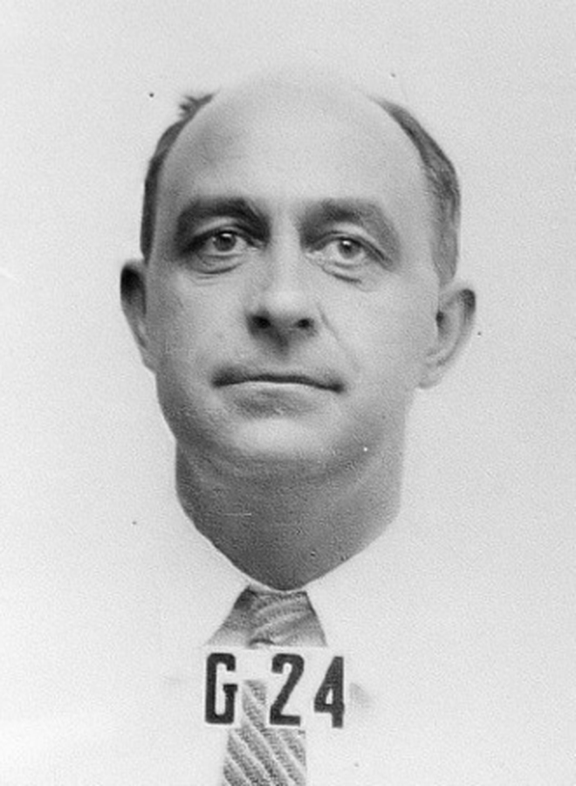
Enrico Fermi, whose paper-scrap estimate of the Trinity blast is the habit every sizing case below tests. Photo: Los Alamos National Laboratory, public domain, via Wikimedia Commons.

6. How many replacement tires are sold in the US each year? (market sizing, top-down, automotive)

The tire case tests whether you can build a clean chain from population to the answer and then check it against a real figure.

The prompt: "How many replacement tires are sold in the United States each year for cars and light trucks?"

Clarifying questions and answers:

- Replacement only, not the tires on new cars? Replacement only.
- Cars, pickups, and SUVs, but not commercial trucks? Right.
- Units, not dollars? Units.

Structure: Start with how many vehicles are on the road, work out how often a vehicle needs a new set of tires, and multiply by four. The vehicle count comes from population; the replacement rate comes from miles driven a year and how many miles a tire lasts. The best top-down chains have four or five links, each one a number you could defend if asked.

The data (my assumptions, stated out loud):

Assumption | Value
US population | About 335 million
Light vehicles on the road | About 280 million (roughly 0.85 per person)
Miles driven per vehicle per year | 12,000
Miles a tire lasts | 48,000
Tires per set | 4

The math:

- A tire lasts 48,000 ÷ 12,000 = 4 years, so each vehicle needs a new set about every 4 years.
- Vehicles replacing a set in any given year: 280 million ÷ 4 = 70 million.
- Tires: 70 million × 4 = 280 million a year.
- Sanity check: the US Tire Manufacturers Association forecast about 260 million replacement passenger and light truck tires for 2025 [VERIFY: USTMA's latest shipment forecast], so the estimate is about 8 percent high. Close enough, and the gap has a reason: not every worn tire gets replaced on schedule.
- Second method, as a cross-check: about 20,000 tire-selling locations × 40 tires a day × 300 days = 240 million. Same neighborhood.
- About 280 million replacement tires a year, within 10 percent of the industry's own count, and the two methods agree.

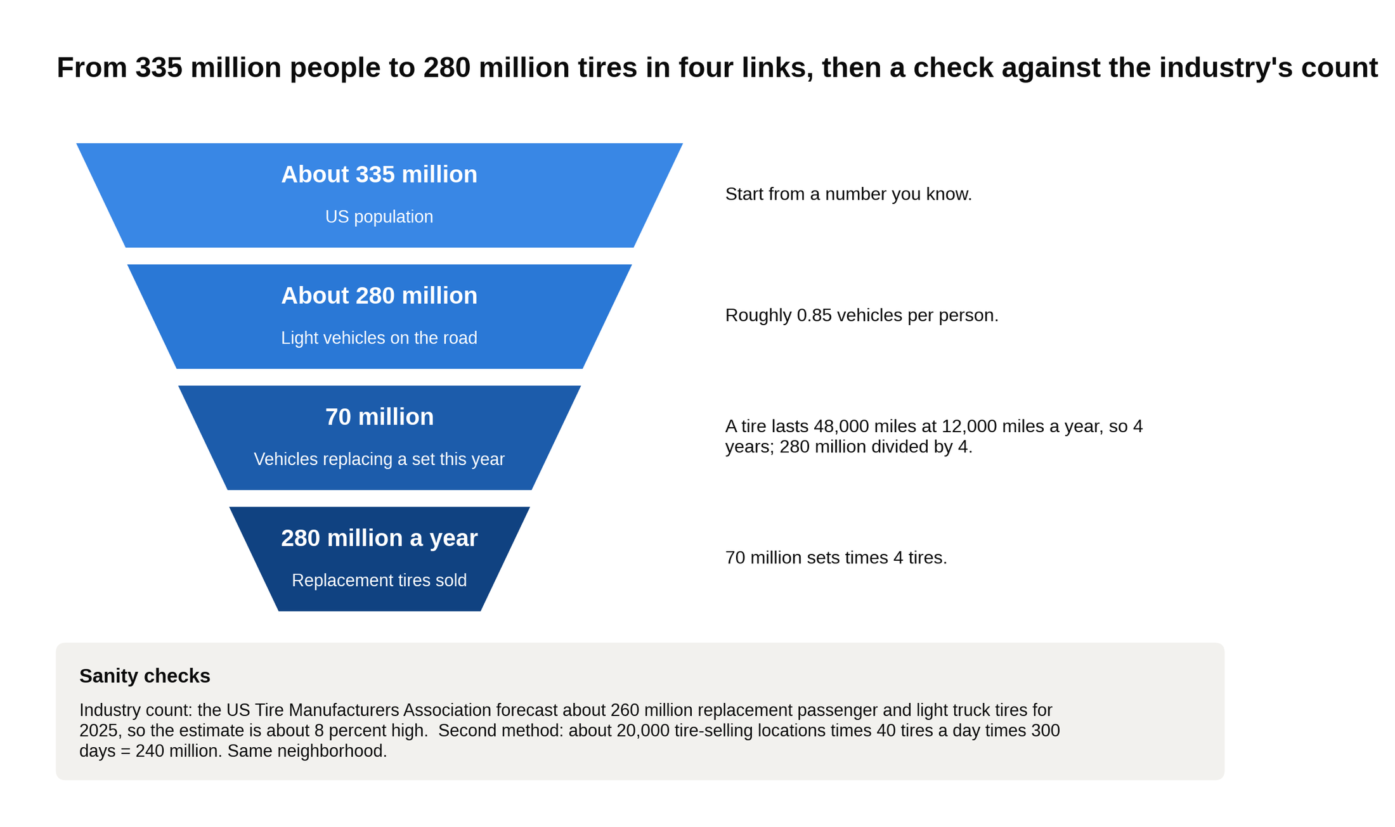
The top-down chain for case 6 has four links, and the two checks at the bottom land within 10 percent of the estimate.

The so what: The interviewer doesn't care about the tire market. They care that you said "12,000 miles a year" and "48,000-mile tire life" as assumptions, not facts, and that you knew which one to doubt. Tire life is the weaker assumption: at 40,000 miles the answer jumps to 336 million. A strong candidate names that before being asked.

A strong recommendation: "About 280 million replacement tires a year, from 280 million vehicles each needing a set every four years. The assumption I'd check first is tire life, since 40,000 miles instead of 48,000 adds 20 percent to the answer. If I were advising a tire retailer, the useful next step is splitting that 280 million by region and by vehicle age, since older cars replace tires more often and that's where a retailer wins share."

What separates a strong candidate from an average one: An average candidate rushes to a number and stops. A strong candidate rounds to make the arithmetic easy, flags the weakest assumption, and cross-checks with a second method or a known figure.

State every assumption as an assumption, round so the math is easy, and name the link in the chain you'd check first.

7. How much revenue does a 10-screen suburban movie theater make a year? (market sizing, bottom-up, cinemas)

The movie theater case tests whether you can build from a single unit and resist the assumption that a theater looks like its Saturday night.

The prompt: "Estimate the annual revenue of a 10-screen movie theater in a US suburb."

Clarifying questions and answers:

- Tickets only, or food and drink too? Both. Ignore advertising and private rentals.
- A typical multiplex, not a luxury dine-in theater? Typical.
- Open every day? Yes, 365 days.

Structure: Ticket revenue is screens times showings a day times seats times the share of seats filled times days times the ticket price. Concessions are tickets times what the average person spends at the stand. The share of seats filled is the number people get wrong, because they picture a packed Friday night and forget the 1 p.m. Tuesday showing playing to six people. Bottom-up sizing lives or dies on the one rate you blend across busy and empty periods.

The data (my assumptions):

Assumption | Value
Screens | 10
Showings per screen per day | 5
Seats per screen | 150
Share of seats filled, blended across the week | 10 percent
Ticket price | $11
Concession spend per ticket | $5

The math:

- Seats available each day: 10 × 5 × 150 = 7,500.
- Tickets sold each day: 7,500 × 10 percent = 750.
- Tickets a year: 750 × 365 = 273,750.
- Ticket revenue: 273,750 × $11 = about $3.0 million.
- Concessions: 273,750 × $5 = about $1.4 million.
- Sanity check: the 2024 US box office was about $8.7 billion across roughly 40,000 screens [VERIFY: Cinema United screen count and the final 2024 domestic box office figure], or about $220,000 a screen, so a 10-screen average is about $2.2 million in tickets. Our $3.0 million is about 40 percent above average, which fits a well-located suburban site, or suggests 10 percent occupancy is a touch generous.
- About $4.4 million a year, roughly $3 million from tickets and $1.4 million from the concession stand, and the national average says that's a good theater, not an impossible one.

The so what: A third of the revenue comes from popcorn and soda, and because the theater keeps far more of each concession dollar than each ticket dollar (studios take a large share of the ticket), the concession stand makes most of the profit. That's the kind of observation that turns a sizing exercise into a business conversation.

A strong recommendation: "About $4.4 million a year. The assumption that drives it is the 10 percent blended occupancy; the national figures suggest the average theater runs closer to 7 percent, so I'd treat $3.5 to $4.5 million as the range. If the client owns this theater, the next question is concession spend per head, because moving it from $5 to $6 adds about $270,000 at almost no cost."

What separates a strong candidate from an average one: An average candidate uses 50 percent occupancy because the shows they attend are full, and lands at $20 million. A strong candidate separates weekday matinees from weekend nights, blends to a low single-digit rate, and checks the result against the national box office.

Blend your rates across the quiet hours and the busy ones, then test the answer against a total you can look up.

Operations, new product, and private equity case interview examples
Operations, launch, and investment cases reward candidates who map the mechanism before touching the numbers: where orders wait, what a policy earns over its life, how a fund's return splits between the plan and the exit. These three are the ones most undergrads have never seen in a textbook, which is why they show up in final rounds: the second-round interviewer wants to know whether you can structure something unfamiliar.

8. A fulfillment center misses its 24-hour promise and costs more per order (operations and cost, e-commerce logistics)

The warehouse case tests whether you can tell a capacity problem from a cost problem when they show up at the same time.

The prompt: "Our client runs a fulfillment center for an online home goods retailer. It promises to ship every order within 24 hours, but orders now take 36 hours on average to leave the building, and labor cost per order has risen from $4.00 to $5.00 in a year. Fix both."

Clarifying questions and answers:

- What's in the $5.00? Warehouse labor only, not shipping.
- Has volume changed? Orders are up from 9,000 to 12,000 a day. Headcount is up from 120 to 160, so both grew a third.
- Has the product range changed? The number of distinct items stocked grew from 5,000 to 9,000, so the building is fuller and pickers walk farther.
- Is space the constraint? No, the building has room. The client thinks it's a process problem.

Structure: Walk one order through the building: it's received and stored, then picked off the shelf, packed into a box, and loaded on a truck. For each step, ask two separate questions: how long does the order wait before that step, and how many minutes of labor does the step consume. Waiting time explains the 36 hours. Labor minutes explain the $5.00. Time problems and cost problems in a warehouse usually have different causes and different fixes, so measure each step for both before recommending anything.

A bottleneck is the step with the least capacity; orders pile up in front of it and the pile is the wait. A useful rule for this, proven by John Little in 1961 and known as Little's Law, says the average number of orders sitting in a building equals the arrival rate times the average time each one spends inside. At 12,000 orders a day and 1.5 days each, that's 18,000 orders in the building at any moment.

The data:

Step | Labor minutes per order | Average wait before this step | Capacity per day
Pick (walk to shelf, grab item) | 8 (5 walking, 3 handling) | 6 hours (overnight orders wait for the morning shift) | 14,000 orders
Pack (box, pad, label) | 3 | 26 hours | 10,000 orders (20 stations × 500)
Ship (sort, load) | 1 | 4 hours (trucks leave twice a day) | 15,000 orders
Total | 12 minutes | 36 hours of waiting, plus 12 minutes of work

Labor costs $25 an hour including benefits. A year ago picking took 6 minutes and packing 2.6 minutes, when the building held 5,000 items.

The math:

- Cost today: 12 minutes × $25 ÷ 60 = $5.00 per order. A year ago: (6 + 2.6 + 1) = 9.6 minutes × $25 ÷ 60 = $4.00. The entire increase is 2 minutes of extra walking per pick and a few seconds of packing.
- The wait: packing handles 10,000 orders a day but 12,000 arrive, so 2,000 a day pile up in front of the pack stations. By Friday the pile is 10,000 orders deep, and the client clears it with weekend overtime. That pile is the 26-hour queue, and it's why orders average 36 hours instead of the 10 they'd take with no backlog.
- Fix one, the wait: add six pack stations. Capacity becomes 26 × 500 = 13,000 a day, above the 12,000 arriving. Once capacity exceeds arrivals, the queue stops growing, the pack wait falls to a couple of hours, and total time drops to about 12 hours. Cost: about $15,000 a station, $90,000.
- Fix two, the cost: batch picking. Instead of walking the aisles for one order, a picker takes a cart and collects eight orders in one trip. Walking falls from 5 minutes to about 2 per order. Picking drops from 8 minutes to 5. Labor per order becomes 5 + 3 + 1 = 9 minutes, or $3.75. Cost: carts and software, about $200,000.
- Savings: $5.00 minus $3.75 = $1.25 an order × 12,000 orders × 300 shipping days = $4.5 million a year, plus the weekend overtime that goes away. Against $290,000 of spending, payback is under a month.
- Six pack stations end the 26-hour queue and batch picking cuts labor to 9 minutes an order, taking cost to $3.75 and shipping time to about 12 hours, for about $290,000 that pays back in weeks.

The so what: The client hired a third more people when volume grew a third and was surprised that cost per order rose. Headcount wasn't the issue. The product range nearly doubled, so every pick got longer, and pack capacity never grew with volume. Two problems that looked like one, with completely different fixes.

A strong recommendation: "Two fixes for two problems. Add six packing stations to lift capacity to 13,000 orders a day, which ends the backlog and brings shipping time under 24 hours within a week. Then move to batch picking, eight orders per cart, which cuts labor from 12 minutes to 9 and cost per order from $5.00 to $3.75, saving about $4.5 million a year. Total spend about $290,000. Risks: batch picking raises mis-pick errors if the sorting step isn't designed well, and volume may pass 13,000 next year, so plan the next six stations now. Next steps: time 50 picks to confirm the walking share, and check the pack stations' real throughput against the 500-a-day figure."

What separates a strong candidate from an average one: An average candidate says hire more people and look at automation. A strong candidate maps the steps, compares each step's capacity to arrivals to find the bottleneck, separates waiting time from working time, and sizes a cheap fix for each.

Find the bottleneck by comparing each step's capacity to the arrival rate, because the step where capacity is lowest is where every order waits.

9. A home-and-auto insurer considers launching pet insurance (new product launch, insurance)

The pet insurance case tests whether you can judge a new product by its unit economics and then find the one advantage that changes the answer.

The prompt: "Our client is a mid-size US home and auto insurer with 10 million customers. It's considering launching pet insurance for dogs and cats. Should it, and how?"

Clarifying questions and answers:

- What's the goal? A profitable new line of business within five years.
- Build it in-house or partner with a specialist? Open to either.
- How big is the market? About 7 million pets were insured in the US in 2025, under 5 percent of the country's dogs and cats, and the market has grown at double-digit rates for a decade [VERIFY: NAPHIA State of the Industry report, latest edition].
- What do the client's customers look like? They own roughly 6 million dogs and cats between them.

Structure: First, is the market worth entering: how many pets are insured, how fast it's growing, who the competitors are. Second, what does one policy earn: the premium, minus claims paid out, minus the cost of running it, minus the cost of winning the customer, over the years the customer stays. Third, what does the client bring that a startup doesn't: 10 million existing customers it can sell to cheaply. Fourth, how to launch and what could go wrong. New product cases turn on the economics of one unit and the cost of acquiring one customer, and a distribution advantage shows up in the second number.

Two terms matter here. The loss ratio is the share of premium paid back out in claims; a 70 percent loss ratio means $70 of every $100 collected goes to vets. Acquisition cost is what it costs in marketing and sales to sign one new policy.

The data:

Item | Value
Average annual premium | $600
Loss ratio | 70 percent, so $420 in claims per policy per year
Admin and claims handling | 15 percent, so $90
Acquisition cost, selling to the general public | $200 per policy
Acquisition cost, cross-selling to existing customers | $50 per policy
Average time a policy stays active | 3 years
One-time launch cost (systems, underwriting, vet network, state filings) | $15 million
Fixed running cost | $5 million a year
Pets owned by the client's customers | About 6 million

The math:

- Contribution per policy per year: $600 minus $420 minus $90 = $90.
- Over a three-year life: 3 × $90 = $270.
- Net of acquisition, open market: $270 minus $200 = $70 per policy. Cross-sell: $270 minus $50 = $220 per policy.
- Fixed costs over five years: $15 million + 5 × $5 million = $40 million.
- Break-even policies, open market: $40 million ÷ $70 = about 571,000 policies. That's 8 percent of every insured pet in America today, from a standing start. Not credible.
- Break-even policies, cross-sell: $40 million ÷ $220 = about 182,000 policies. That's 3 percent of the 6 million pets the client's customers already own. Credible.
- At 5 percent penetration, 300,000 policies: 300,000 × $220 = $66 million over five years, minus $40 million of fixed cost, so $26 million ahead. At steady state, 300,000 × $90 = $27 million a year of contribution against $5 million of fixed cost.
- Sold to strangers, the product needs 571,000 policies to break even; sold to the client's own customers, it needs 182,000, 3 percent of the pets they already own, so the distribution advantage is the entire case.

The so what: The product's economics are ordinary. $90 a year per policy is thin, and a startup paying $200 to win each customer barely covers its fixed costs. What the client has that the startup doesn't is 10 million households who already open its emails. Build the launch around that, and avoid the $15 million of fixed cost at first by letting a specialist underwriter carry the risk and the systems while the client sells.

Pet insurance is newer than most people think. The first US policy was issued in 1982 by Veterinary Pet Insurance, now part of Nationwide, and it covered Lassie, the television collie, who attended the press conference. Four decades later, more than 95 percent of American dogs and cats are still uninsured, which is why insurers keep looking at this case.

A strong recommendation: "Launch it, but only as a cross-sell to existing customers, and partner with a specialist underwriter for the first two years rather than spending $15 million to build it. Break-even is about 182,000 policies through the customer base versus 571,000 in the open market; at 5 percent penetration the line earns about $22 million a year at steady state, before the cost of replacing policies that lapse. Risks: vet costs rising faster than premiums, which pushes the loss ratio past 70 percent; adverse selection, where the owners most likely to buy are the ones with sick pets; and brand damage if claims get denied. Next steps: survey 5,000 customers on willingness to pay, pilot in three states, and negotiate a partner deal where the client earns a commission before it takes underwriting risk."

What separates a strong candidate from an average one: An average candidate talks about pet humanization and a growing market. A strong candidate computes the contribution per policy, compares the two acquisition costs, finds the break-even, and converts it into a penetration rate the CEO can judge.

Judge a new product by what one unit earns over its life minus what it costs to win the customer, then look for the asset that changes the second number.

10. A private equity fund weighs buying a car wash chain (private equity due diligence, car washes)

The car wash case tests whether you can run the deal math, then run it again with the plan half-finished, and turn the gap into a diligence list.

The prompt: "A middle-market private equity fund is in the final round to buy a 30-location express car wash chain in Florida for $150 million. The partner wants your view: is this a good deal, and what should diligence focus on?"

Clarifying questions and answers:

- What return does the fund need? About 25 percent a year, or roughly three times its money in five years.
- How much can it borrow? Lenders will lend five times EBITDA.
- Does the chain have a growth plan? Yes: 20 new sites in the first two years at about $4 million each, so all of them are mature by the time the fund sells.
- How does a site make money? Monthly members who pay $25 for unlimited washes, plus one-off retail washes at $16. Each site has about 1,800 members.

Structure: Four questions. Is this a good business: recurring membership revenue, light labor, and how crowded Florida is with new washes. Is the price fair: the entry multiple against what similar chains have sold for. Where does the return come from: new sites, more members per site, higher prices, and the multiple at exit. And what does the deal look like if the plan only half works. The last question is the one that becomes the diligence list. A private equity case is a profitability case with a financing layer and an exit on top, so build the business first and the returns second.

Three terms. EBITDA, again, is the cash-like operating profit deals are priced on. MOIC is the multiple of invested capital: equity out divided by equity in. IRR is the yearly rate of return that gets you from one to the other; a quick rule is that 2x in five years is about 15 percent, 3x is about 25 percent, and 4x is about 32 percent.

The data:

Item | Value
Sites today | 30
Members per site | 1,800 at $25 a month
Retail washes per site | 60,000 a year at $16
Site-level EBITDA margin | 45 percent
Corporate overhead | $2.25 million today, $3.5 million at 50 sites
Price | $150 million
Debt available | 5x EBITDA
Growth plan | 20 new sites at $4 million each, built in years one and two, each reaching $1.5 million of revenue three years after opening
Membership plan | Lift members per site from 1,800 to 2,500; incremental margin 70 percent
Exit assumption | 9x EBITDA in year five

The math:

- Revenue per site: 1,800 × $25 × 12 = $540,000 from members, plus 60,000 × $16 = $960,000 retail, so $1.5 million. Site EBITDA at 45 percent: $675,000.
- Chain EBITDA today: 30 × $675,000 minus $2.25 million overhead = $18.0 million. Entry multiple: $150 million ÷ $18 million = 8.3x.
- Financing: debt 5 × $18 million = $90 million. Equity $60 million.
- Membership lever: 700 more members × $25 × 12 = $210,000 of revenue per site. At a 70 percent incremental margin, $147,000 of EBITDA per site. Site EBITDA rises to $822,000.
- Year five: 50 sites × $822,000 = $41.1 million, minus $3.5 million overhead = $37.6 million of EBITDA.
- Exit: 9 × $37.6 million = $338 million. The $80 million of new sites is funded from the business's cash flow plus $30 million of extra debt, and $20 million of the original loan is repaid along the way, so net debt at exit is about $100 million. Equity: $338 million minus $100 million = $238 million.
- Return: $238 million ÷ $60 million = 4.0x. Over five years that's about a 32 percent IRR. Well above the 25 percent target.
- Downside: only 10 new sites get built and membership stays at 1,800. EBITDA: 40 × $675,000 minus $3.0 million = $24 million. Exit at 8x, since a chain that stopped growing earns a lower multiple: $192 million. Net debt about $95 million. Equity $97 million. Return: 1.6x, about a 10 percent IRR.
- The base case returns 4.0x and a 32 percent IRR, but with half the sites built and flat membership the same deal returns 1.6x and 10 percent, so the entire return depends on whether new sites really ramp to $1.5 million.

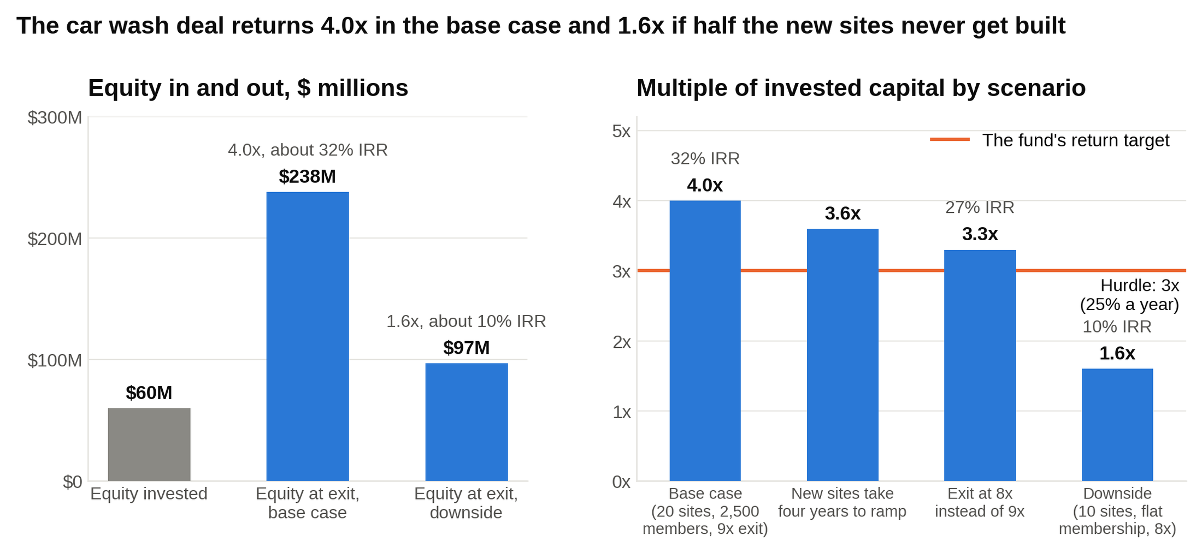
Three of the four cases clear the fund's 3x hurdle; the one that doesn't is the one where the new sites never get built, which is why diligence goes there.

The so what: The business is good: a third of revenue is subscription, labor is light, and 8.3x is a sensible entry price. The return comes from the 20 sites the fund hasn't built yet and from paying 8.3x and selling at 9x, not from the business as it stands today. Diligence should spend its time on those two assumptions. Also watch the member who washes four times a month: at $16 a wash that's $64 of retail value for a $25 fee, so a membership base full of heavy users can cost more than it earns.

The biggest US chain is a live example of this model. Mister Car Wash reported 1.4 million Unlimited Wash Club members in the filing for its June 2021 IPO, accounting for 62 percent of its wash volume, and its private equity owner, Leonard Green & Partners, had bought the chain in 2014 for $520 million. In February 2026 Leonard Green announced it would take the company private again [VERIFY: status of the Leonard Green take-private of Mister Car Wash]. Membership is what made a car wash chain look like a subscription business to investors.

A strong recommendation: "Proceed to a bid at or below $150 million, conditional on three diligence findings. First, site-level profit and loss for all 30 sites, to confirm the $675,000 average isn't five great sites carrying 25 weak ones. Second, the ramp curves of the last five openings, because if new sites take four years rather than three to reach $1.5 million, half of them are still ramping at exit and the base case slips to about 3.6x. Third, member churn and the share of members washing more than three times a month. I'd also underwrite the exit at 8x, not 9x, since paying 8.3x and assuming 9x is counting on the market, not the plan. At 8x the base case is about 3.3x and a 27 percent IRR, which still clears the hurdle. Risks: new express washes opening within three miles of existing sites, hurricane season, and labor costs. Next step: get the site-level data before the final bid."

What separates a strong candidate from an average one: An average candidate computes 4x, says it clears the hurdle, and recommends buying. A strong candidate runs a downside case, questions the exit multiple, and turns every weak assumption into a diligence question with a number attached.

Run the downside before you recommend a deal, because the assumptions that collapse in the downside are the ones diligence exists to test.

How to use these case interview examples
Reading a solved case teaches you what good looks like; speaking an unsolved one builds the skill, so use these ten as answer keys, not as reading. Cover everything below the prompt and run the case out loud with a partner who holds the data and shares numbers only when asked. Spend 20 to 25 minutes on the case and 10 on feedback: did the structure fit the question, did the math tie, did the close lead with the answer. Then compare your path to the one above. The differences are the lesson.

Practice both interviewer-led and candidate-led styles, because the firms run cases differently. When I interviewed at McKinsey, the interviewer walked me through the case in steps: here's the structure question, now here's an exhibit, now compute this. BCG and Bain give you the prompt and let you decide where to go, which is why every case above opens with the clarifying questions and the structure before any number: in a candidate-led case, that opening is yours to run. The McKinsey case interview guide covers the interviewer-led version in detail.

Between partner sessions, drill the arithmetic that showed up in every case here: percentages of large numbers, splitting a change into price and volume, dividing by 12, break-even volumes, and the MOIC-to-IRR rule of thumb. Record one case a week and listen for silences longer than ten seconds and for math you did in your head without saying it. Both lose points.

Spread the work over weeks, because what you're building is the calm to think with someone watching, and that comes only from repetition. For the full plan, see how to prepare for a consulting interview and these 10 tips to beat the case interview.

What to say in a case: say this, don't say that
The same four moments decide every case above: the structure, the math, the "so what," and the close, so script how you handle each one.

Presenting the structure
Don't say: "I'd use the profitability framework and look at revenue and costs."
Say: "Profit fell $40 million while revenue grew, so I'd start on the cost side. An airline's big costs are fuel, crew, maintenance, airport fees, and the planes themselves. Fuel is the one that moves with the market, so that's where I'd look first."

Doing the math
Don't say: nothing, for 45 seconds, then "about $42 million."
Say: "105 million gallons at 40 cents more each. 100 million times 40 cents is $40 million, plus 5 million times 40 cents is $2 million, so $42 million."

Reading a number
Don't say: "So fuel went up $54.5 million."
Say: "Fuel went up $54.5 million, and $42 million of that is the price, not the extra flying. The airline grew fine; it just didn't pass the fuel price through."

Handling an assumption you're unsure of
Don't say: "Let's say tires last 50,000 miles."
Say: "I'll assume a tire lasts about 48,000 miles. That's the assumption I'm least sure of, so I'll flag it and come back to it at the end."

Closing the case
Don't say: "So in summary, we looked at revenue and costs, and there are a few options the client could consider."
Say: "Don't match the $12 price. Launch three tiers instead. The cut costs $48 million a year with certainty; the tiers net about $10 million. The risk is more downgrades than the survey shows, so I'd launch to new customers first and measure."

When the interviewer pushes back
Don't say: "Oh, you're right, I guess that doesn't work."
Say: "Fair point. If new sites take four years instead of three, the base case drops from 4x to about 3.6x. That still clears the hurdle, but it means the ramp data is the first thing I'd want in diligence."

Lead with the answer, attach the number, name the risk, and stop; everything else in a close is filler the interviewer will hold against you.

What about the firms' own practice cases not on this list?
The firms publish free practice cases, and you should do every one of them, because nothing else shows you each firm's style as directly. They aren't reproduced here because they're copyrighted and already covered elsewhere on this site.

- McKinsey posts Beautify, Diconsa, Electro-Light, and Talbot Trucks on its interviewing page, with guidance on the Personal Experience Interview.
- BCG runs a case interview preparation page with its own dos and don'ts and a link to OneDay@BCG, a free job simulation.
- Bain posts Coffee Shop Co. and FashionCo. on its case interview page.

Do the firm cases after you've run the ten here, not before, so you meet each firm's format with the fundamentals already in place. For books, Case in Point by Marc Cosentino is the standard start and Case Interview Secrets by Victor Cheng is strong on building your own structure; one is enough. After one book, every hour is better spent on live cases with a partner. These 10 free case prep resources rank where to find those partners and what else is free.

Where to start this week
Run the case type you'd least like to see in a first round, out loud, with a partner, before the weekend. For most students that's the M&A case or the private equity case, because the vocabulary is new. Do it badly once with these solutions as the answer key, and the second time the vocabulary will be yours.

The piano tuner question was never about piano tuners. It was about whether a student could get to a defensible number from what they already knew. Every case interview is that classroom: the interviewer already knows the answer and wants to watch you reason your way to it, out loud, one defensible step at a time.

